**TRAINER PLC OMRON CP2E N30DRA**

**DAN HMI Weintek MT8072IP**

Gambar Bagian dan Spesifikasi

1. IP Address Komponen
   1. IP Address PLC : 169.254.84.210
   2. IP Address HMI : 169.254.84.200
   3. IP Address PC : Sesuaikan dengan 169.254.84.xxx
2. Gambar Bagian dan Spesifikasi
   1. Gambar Bagian dan Spesifikasi

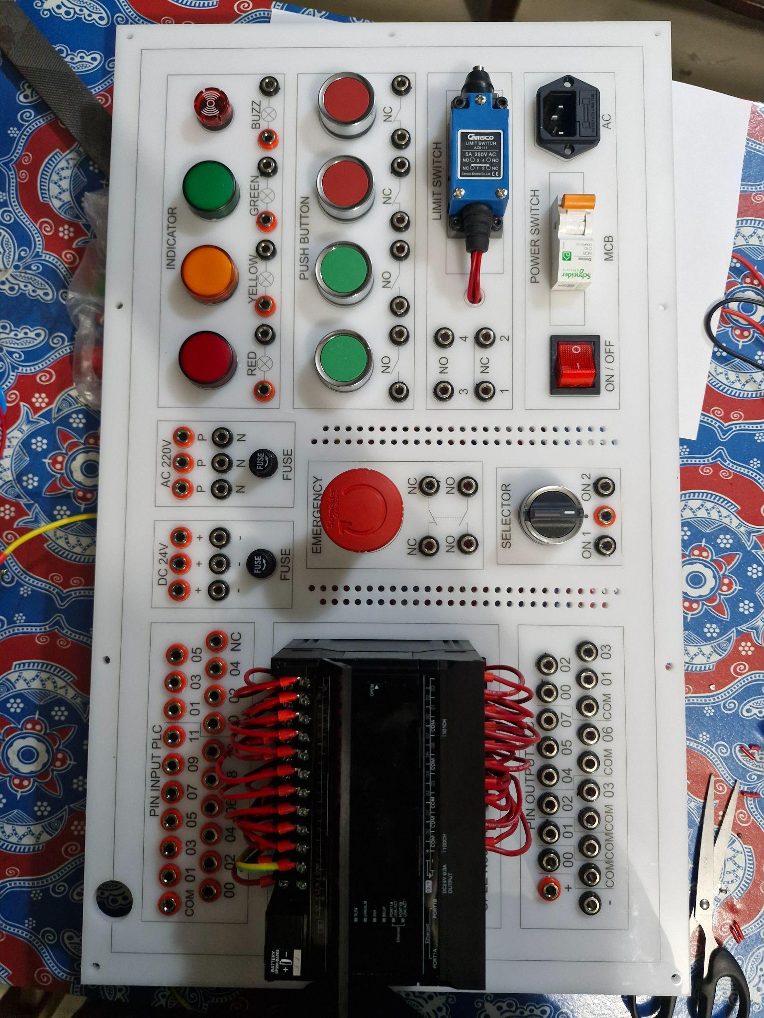

1. Spesifikasi
   1. PLC Omron CP2E N30DRA
   2. HMI Weintek MT8072IP
   3. Socket Power 220VAC
   4. MCB 1 Phase **10A**
   5. Saklar On/Off
   6. Fuse 5A/10A
   7. Button Emergency NO dan NC
   8. Selektor 3 mode atau 2 kontak NO
   9. Button NO hijau
   10. Button NC Merah
   11. Lampu Indikator Merah 220VAC
   12. Lampu Indikator Kuning 220VAC
   13. Lampu Indikator Hijau 220VAC
   14. Buzzer 220VAC
   15. Banana Jack Female 22mm merah
   16. Banana Jack Female 22mm hitam
   17. Banana Jack Male Merah
   18. Banana Jack Male Hitam
   19. Socket RJ45 Male to Female
   20. Socket RS232 Male to Female
   21. Socket USB Male to Female
2. Gambar Wiring

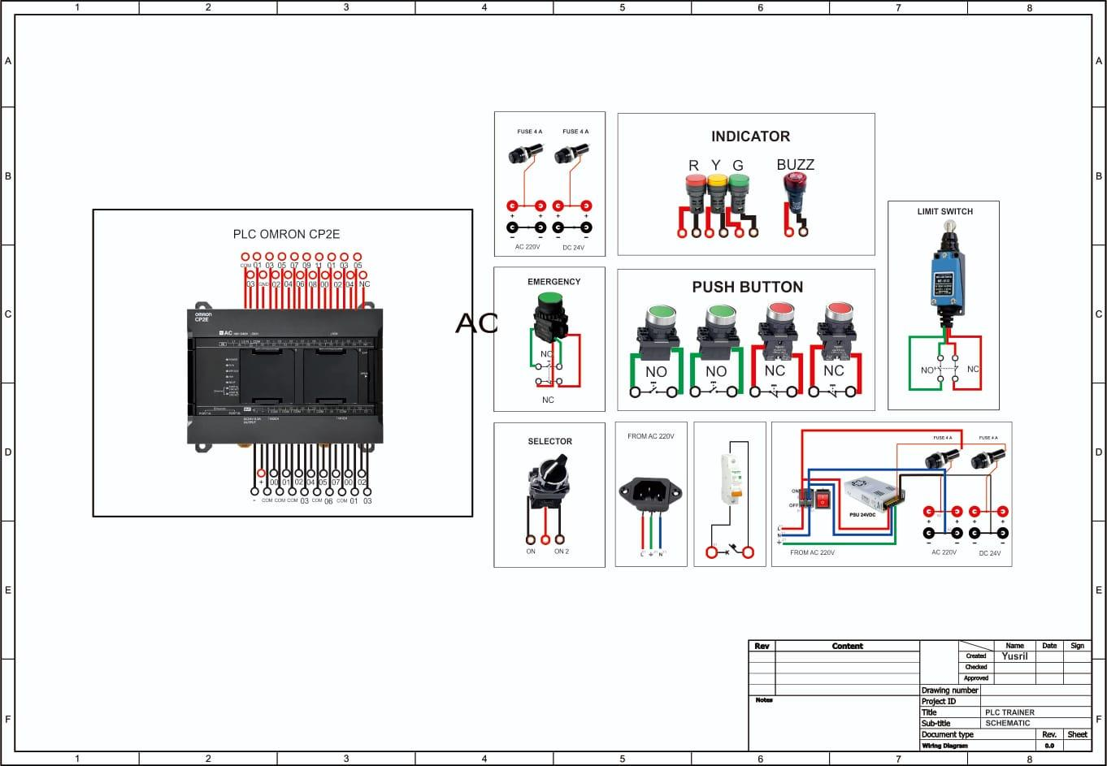

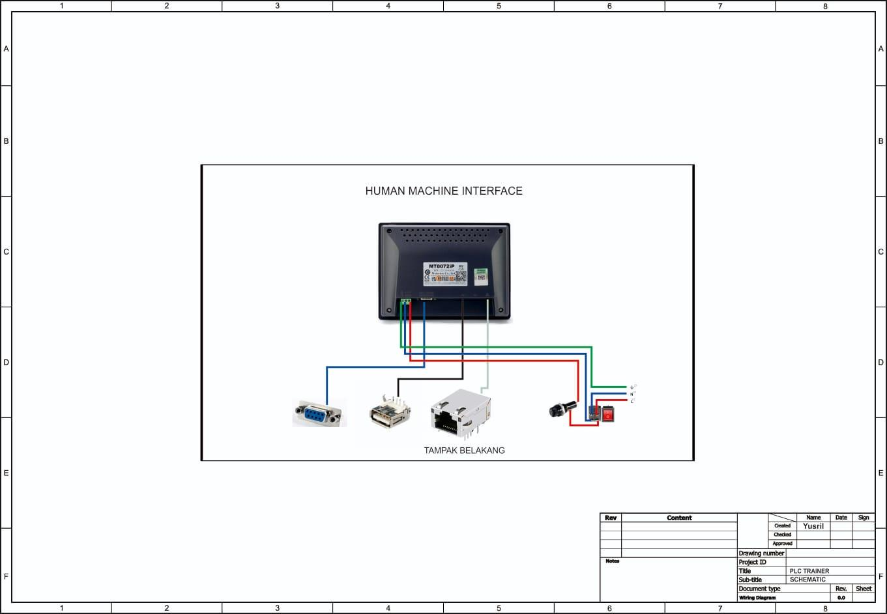

1. Gambar Komunikasi
   1. PC to PLC

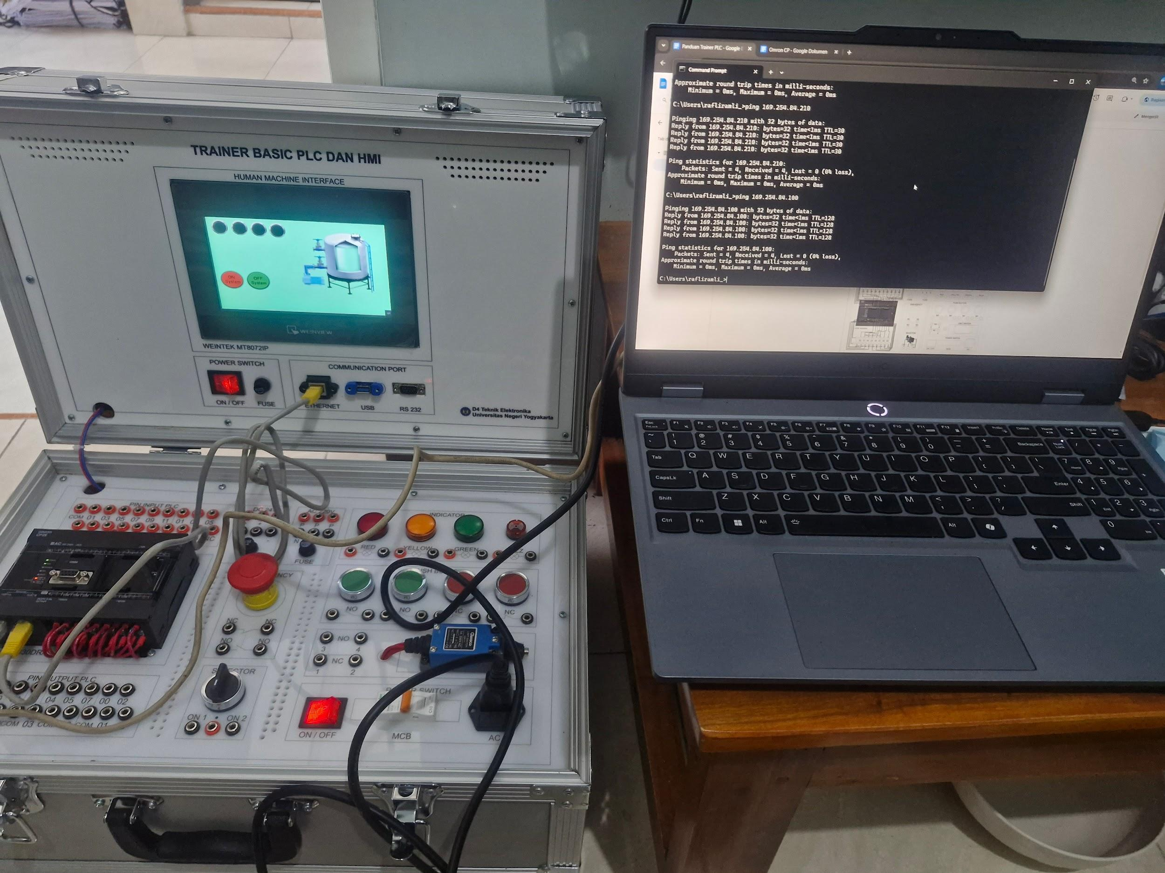

* 1. PLC to HMI

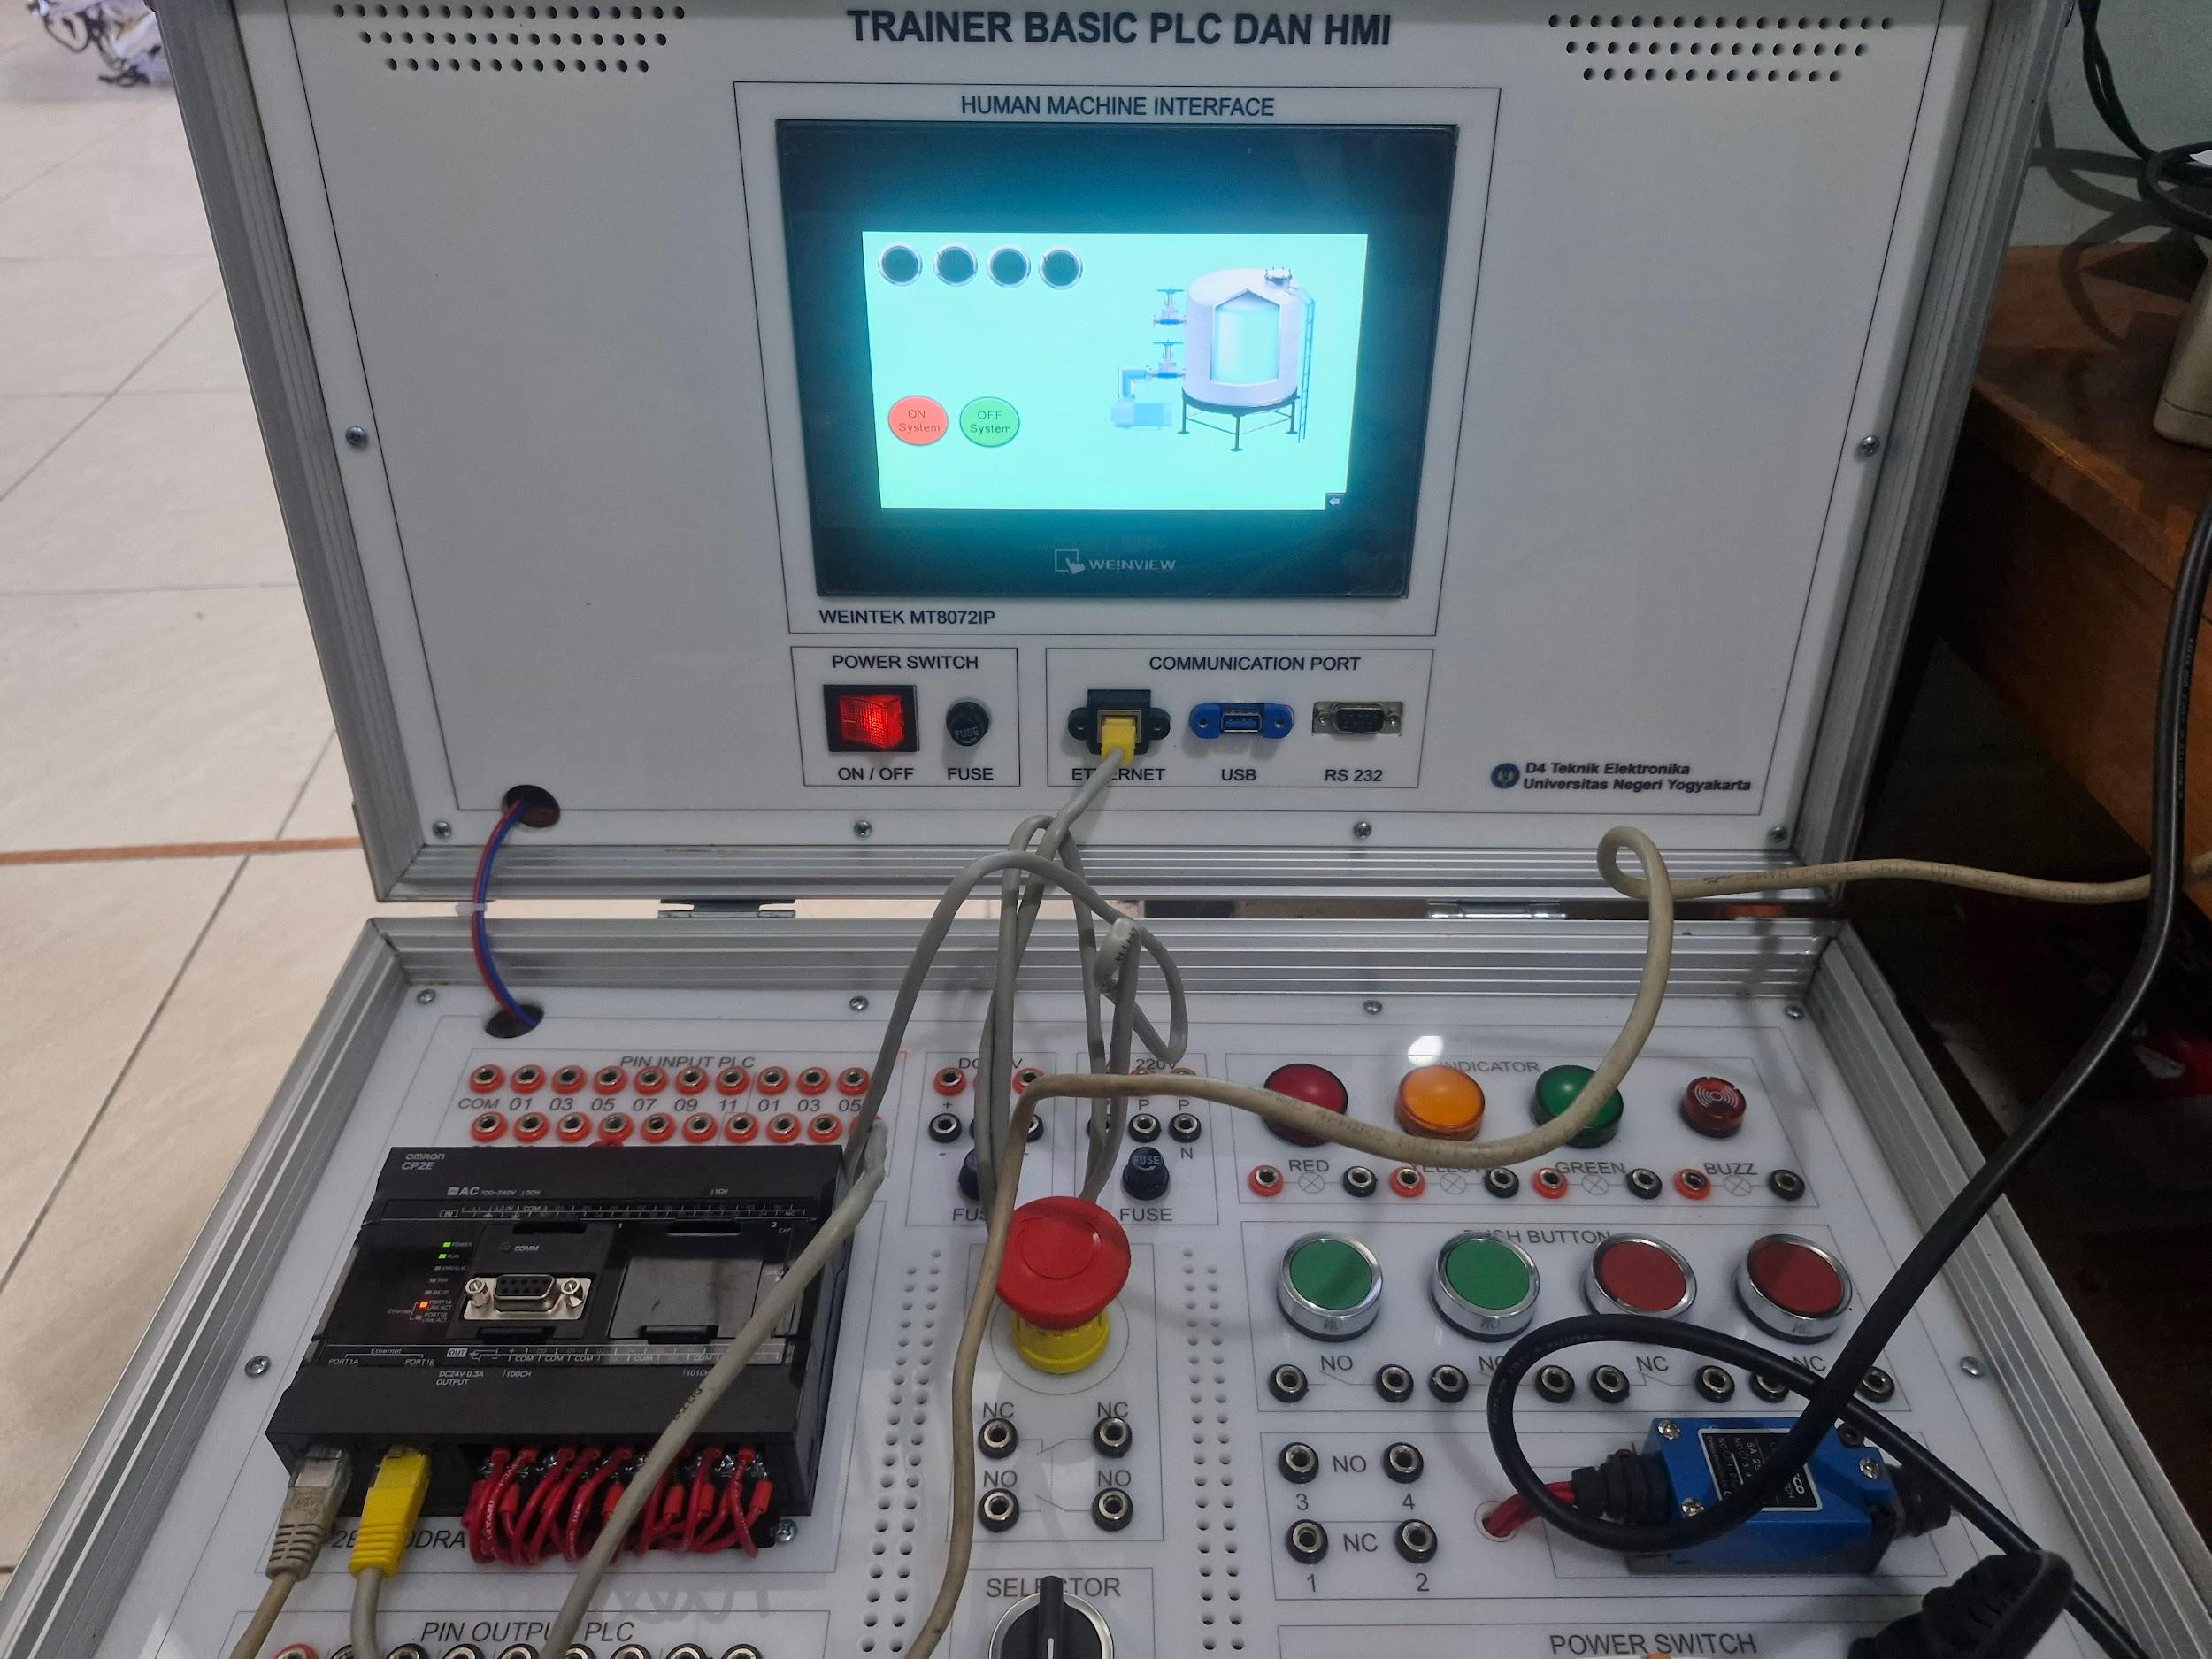

Tutorial Cx-Programmer

1. Buka Software Cx-Programmer
2. Klik New

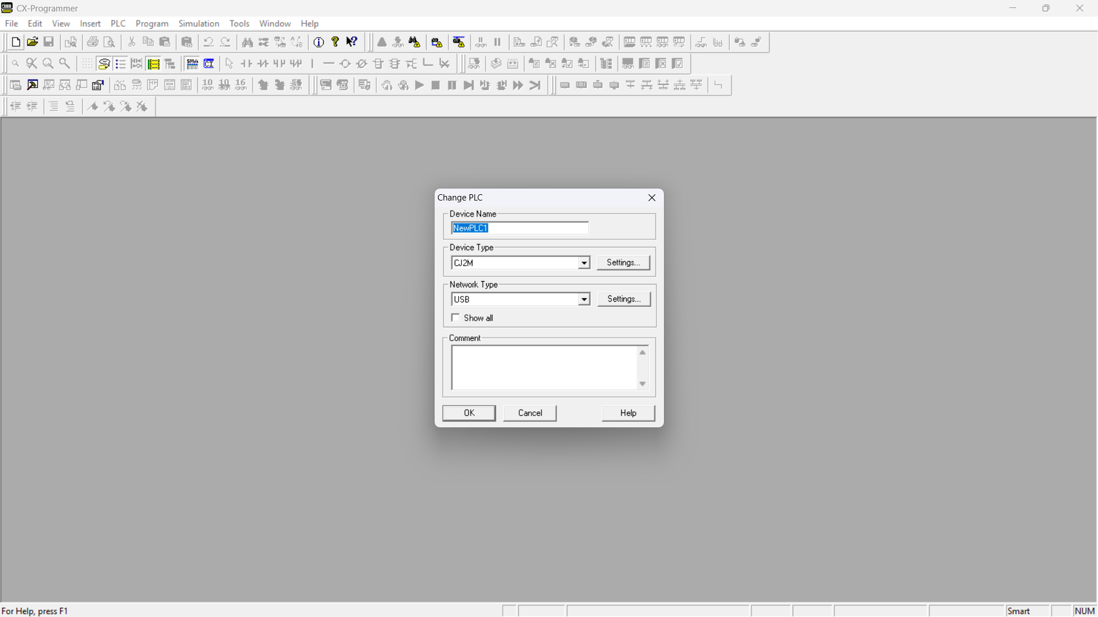

1. Setting device type

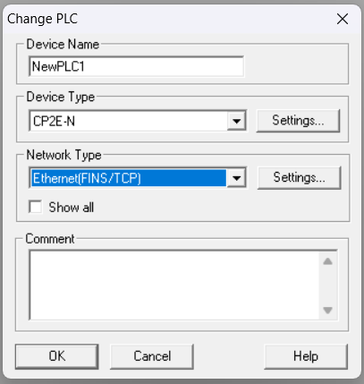

1. Klik Ok dan buat program seperti dibawah ini

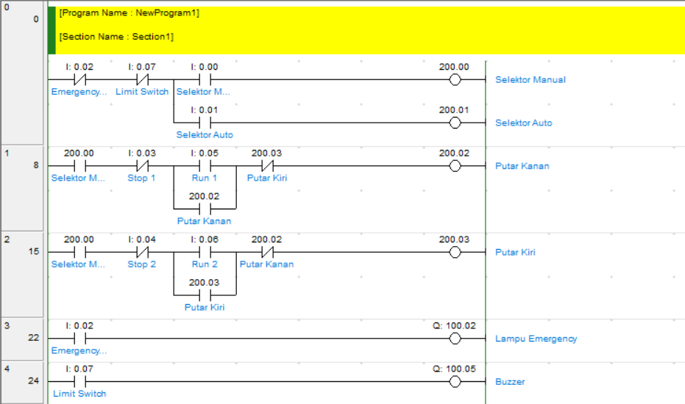

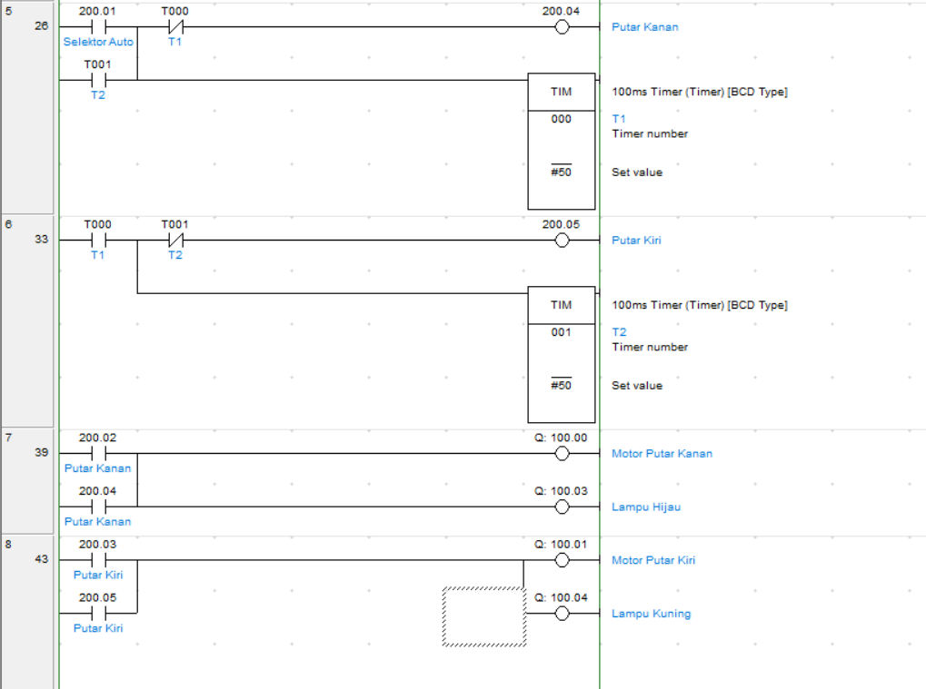

1. Tuliskan Alamat Input dan Outputnya.
2. coba program dengan work online

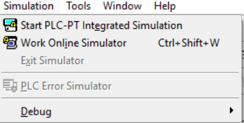

1. lalu transfer kedalam PLC

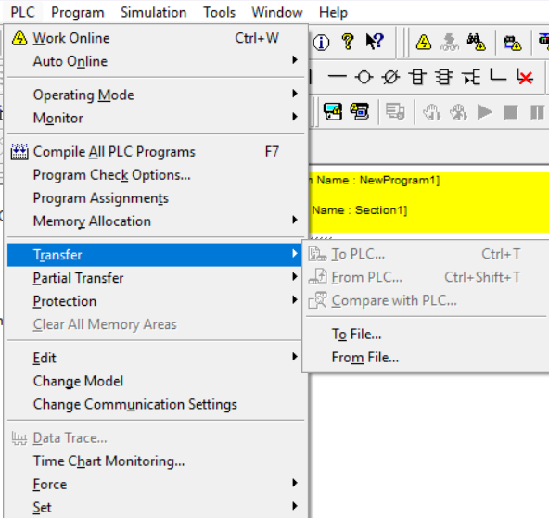

1. Lalu masuk kedalam Run Mode/Monitoring Mode

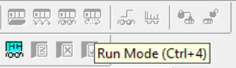

Tutorial Easy Builder Pro

1. Buka Software Easybuilder Pro
2. klik New
3. pilih HMI yang sesuai

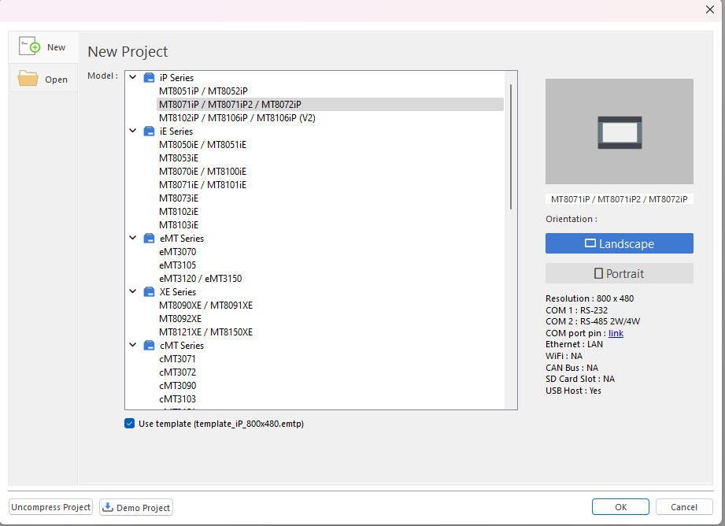

1. lalu tekan OK
2. pilih New Device/Server

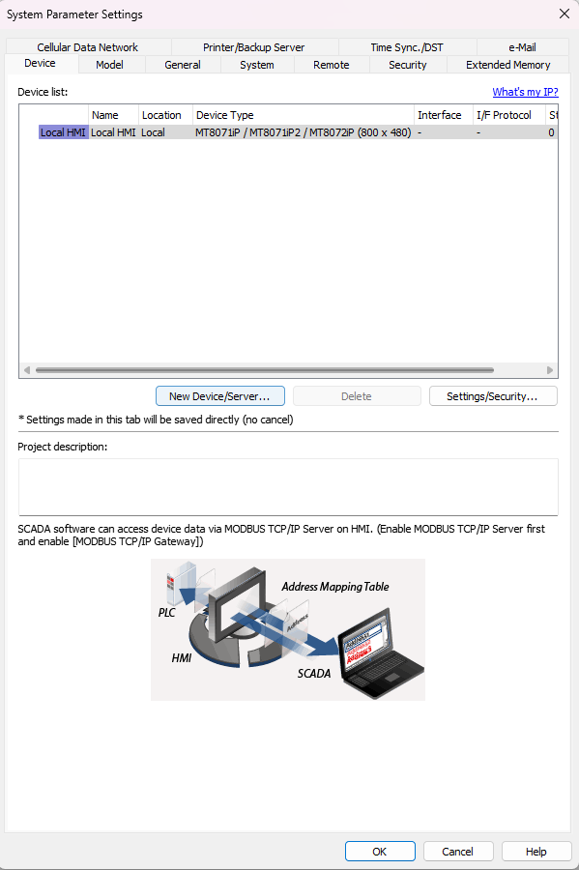

1. pilih tipe device

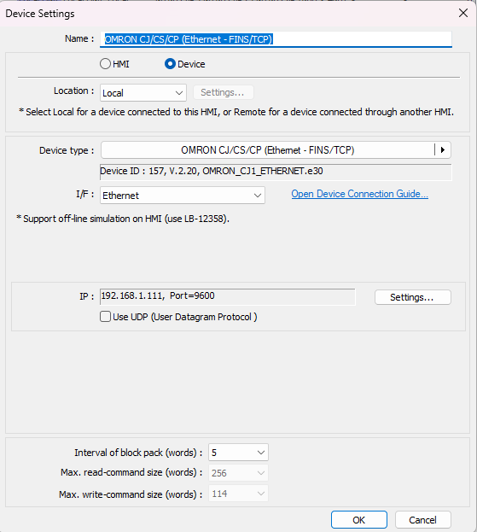

1. sesuaikan dengan PLC yang digunakan
2. pilih komunikasi ethernet FINS/TCP
3. setting IP sesuai dengan IP PLC yang digunakan



1. lalu OK
2. pilih window mana yang mau digunakan

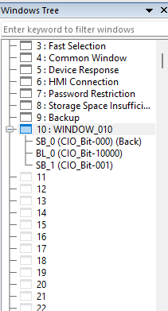

1. masuk ke menu object
2. pilih set bit

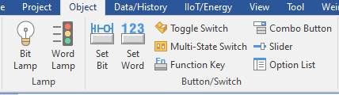

1. drag ke tengah
2. atur pada general seperti gambar berikut

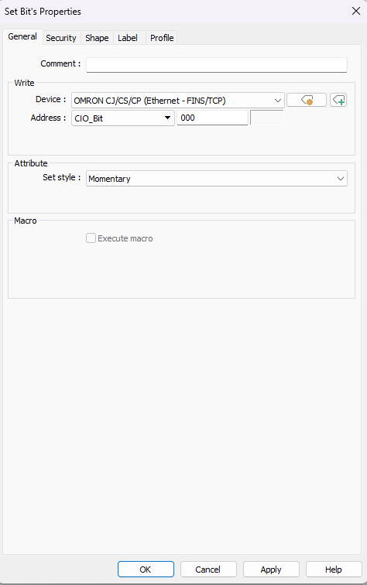

1. lalu apply dan OK
2. ulangi untuk tombol selanjutnya
3. pilih bit lamp untuk menambahkan lampu indikator
4. atur seperti gambar berikut

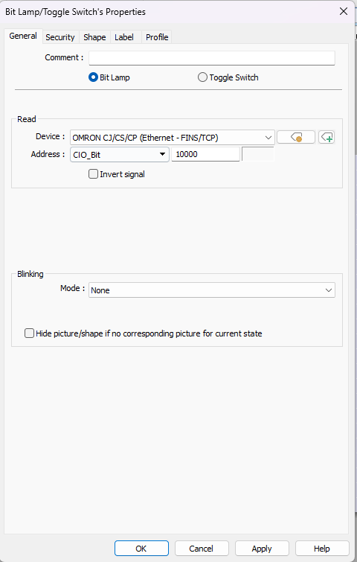

1. lalu apply dan OK
2. pergi ke menu project
3. pilih Download PC > HMI

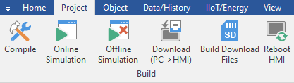

1. cari IP/HMI Name

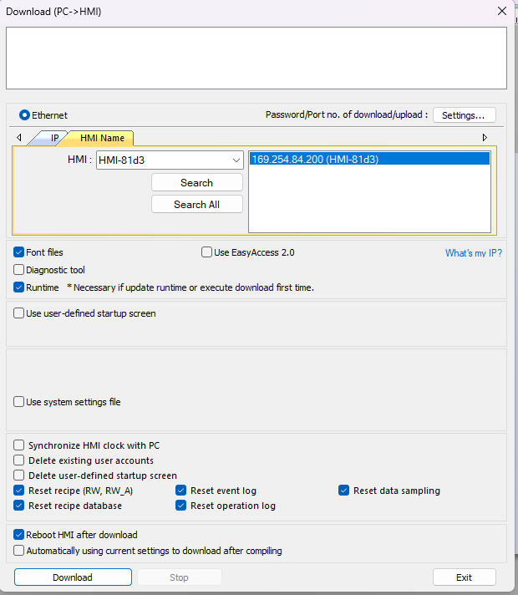

1. klik download
2. lalu klik online simulation
3. HMI dapat digunakan

Tutorial Komunikasi HMI - PLC dengan Ethernet

**OMRON CJ/CS/CP (Ethernet - FINS/TCP)**

Supported Series: OMRON CJ Series, CS Series, CP Series +Ethernet Module. (Ethernet FINS)

Website: <http://www.omron.com/>

*On initialization, switch from RUN MODE to MONITOR MODE.

**HMI Setting:**

| **Parameters** | **Recommended** | **Options** | **Notes** |
| --- | --- | --- | --- |
| **PLC type** | OMRON CJ/CS/CP (Ethernet - FINS/TCP) | |  |
| **PLC I/F** | Ethernet |  |  |
| **Port no.** | 9600 |  |  |
| **PLC sta. no.** | 0 |  |  |

**PLC Setting:**

| **Communication mode** | Ethernet (FINS/TCP) protocol |
| --- | --- |

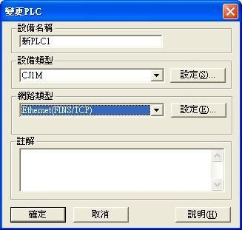

**Import Tags:**

1. Export the **\*.cxr** file in cx-programmer -> variables

**[Important]:** Only addresses with tag name can be imported, and address type is required



1. Open EasyBuilder Pro, and set the drive parameters in **[System Parameter Settings]**, click [**Import Tags]**.



1. Select *.cxr file

1. Check the TAG that the project needs to use.

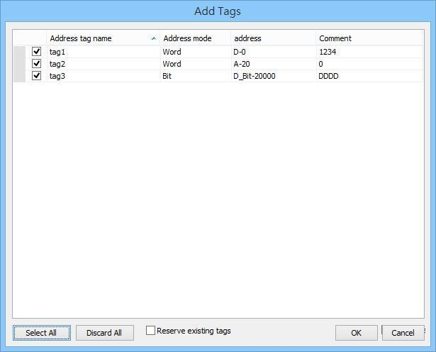

1. Imported tag information successfully.

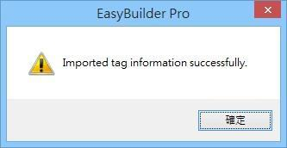

**Device Address:**

| **Bit/Word** | **Device type** | **Format** | **Range** | **Memo** |
| --- | --- | --- | --- | --- |
| B | CIO_Bit | DDDDDdd | 0 ~ 3276715 | Channel I/O (CIO) |
| B | W_Bit | DDDDDdd | 0 ~ 3276715 | Work Area (WR) |
| B | H_Bit | DDDDDdd | 0 ~ 3276715 | Holding Area (HR) |
| B | A_Bit | DDDDDdd | 0 ~ 3276715 | Auxiliary Relay (AR) |
| B | D_Bit | DDDDDdd | 0 ~ 3276715 | Data Memory (DM) |
| B | T_Bit | DDDDDdd | 0 ~ 3276715 | Timer (TIM) |
| B | C_Bit | DDDDDdd | 0 ~ 3276715 | Counter (CNT) |
| B | C_Flag | DDDD | 0 ~ 4095 |  |
| B | T_Flag | DDDD | 0 ~ 4095 |  |
| B | EM0_Bit ~  EM18_Bit | DDDDDdd | 0 ~ 3276715 | Extend Memory |
| W | CIO | DDDDD | 0 ~ 32767 | Channel I/O (CIO) |
| W | W | DDDDD | 0 ~ 32767 | Work Area (WR) |
| W | H | DDDDD | 0 ~ 32767 | Holding Area (HR) |
| W | A | DDDDD | 0 ~ 32767 | Auxiliary Relay (AR) |
| W | C | DDDDD | 0 ~ 32767 | Counter (CNT) |
| W | T | DDDDD | 0 ~ 32767 | Timer (TIM) |
| W | D | DDDDD | 0 ~ 32767 | Data Memory (DM) |
| W | EM0 ~ EM18 | DDDDD | 0 ~ 32767 | Extend Memory |

**Wiring Diagram:**

**Diagram 1**

**Ethernet cable:**

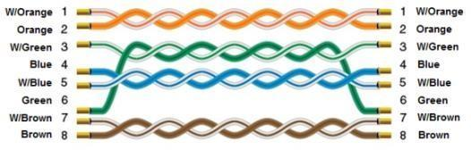

Tutorial Komunikasi HMI TO PLC dengan RS232

**OMRON CJ/CS/CP**

Supported Series: OMRON CP1E, CP2E, CP1L, CP1H, CJ1M, CJ2M, CJ1H, CJM1G, CS1H and CS1G. (Host Link Protocol FINS command), this driver supports Extend Addressing Mode.

Website: <http://www.omron.com/>

**HMI Setting:**

| **Parameters** | **Recommended** | **Options** | **Notes** |
| --- | --- | --- | --- |
| **PLC type** | OMRON CJ/CS/CP | |  |
| **PLC I/F** | RS232 | RS232, RS422, RS485 |  |
| **Baud rate** | 9600 | 9600~115200 |  |
| **Data bits** | 7 | 7 or 8 |  |
| **Parity** | Even | Even, Odd, None |  |
| **Stop bits** | 2 | 1 or 2 |  |
| **PLC sta. no.** | 0 | 0-31 | Host Link Station No. |
| **Protocol** | Multi-read | Multi-read / Single read |  |

| **Online simulator** | YES | **Extend** | **address** | YES |
| --- | --- | --- | --- | --- |
| **Broadcast** | NO |  |  |  |
| **Communication** | Host Link Protocol |

*Support communications between HMI and PLC in pass-through mode *Set LW-9903 to 2 to enhance the speed of download/upload PLC program in pass-through mode **PLC Setting: mode**

**Device Address:**

| **Bit/Word** | **Device type** | **Format** | **Range** | **Memo** |
| --- | --- | --- | --- | --- |
| B | CIO_Bit | DDDDDdd | 0 ~ 3276715 | Channel I/O (CIO) |
| B | W_Bit | DDDDDdd | 0 ~ 3276715 | Work Area (WR) |
| B | H_Bit | DDDDDdd | 0 ~ 3276715 | Holding Area (HR) |
| B | D_Bit | DDDDDdd | 0 ~ 3276715 | Data Memory (DM) |
| B | A_Bit | DDDDDdd | 0 ~ 3276715 | Auxiliary Relay (AR) |
| B | T_Bit | DDDDDdd | 0 ~ 3276715 | Timer (TIM) |
| B | C_Bit | DDDDDdd | 0 ~ 3276715 | Counter (CNT) |
| **Bit/Word** | **Device type** | **Format** | **Range** | **Memo** |
| B | C_flag | DDDD | 0 ~ 4095 |  |
| B | T_flag | DDDD | 0 ~ 4095 |  |
| B | LR_Bit | DDDdd | 0 ~ 19915 |  |
| B | EM0_Bit ~  EM18_Bit | DDDDDdd | 0 ~3276715 | Extend Memory |
| W | T | DDDDD | 0 ~ 32767 | Timer (TIM) |
| W | H | DDDDD | 0 ~ 32767 | Holding Area (HR) |
| W | D | DDDDD | 0 ~ 32767 | Data Memory (DM) |
| W | A | DDDDD | 0 ~ 32767 | Auxiliary Relay (AR) |
| W | W | DDDDD | 0 ~ 32767 | Work Area (WR) |
| W | C | DDDDD | 0 ~ 32767 | Counter (CNT) |
| W | CIO | DDDDD | 0 ~ 32767 | Channel I/O (CIO) |
| W | EM0 ~ EM18 | DDDDD | 0 ~ 32767 | Extend Memory |
| W | LR | DDD | 0 ~ 199 |  |

**Import Tags:**

1. Export the **\*.cxr** file in cx-programmer -> variables

**[Important]:** Only addresses with tag name can be imported, and address type is required



1. Open EasyBuilder Pro, and set the drive parameters in **[System Parameter Settings]**, click [**Import Tags]**.



1. Select *.cxr file

1. Check the TAG that the project needs to use.



1. Imported tag information successfully.



**Wiring Diagram:**

# **Diagram 1**

**RS-232**

The serial port pin assignments may vary between HMI models, please click the following link for more information.



# **Diagram 2**

**RS-485 4W (**CP1H/CP1L CP1W-CIF11 RS485 4W : 9P D-Sub to Termainals)

The serial port pin assignments may vary between HMI models, please click the following link for more information.

| **HMI** |  | **PLC** |
| --- | --- | --- |
| [**Link**](https://dl.weintek.com/public/PLC_Connect_Guide/HMI_Pin_Assignment.pdf) | CP1W-CIF11 RS485 4W Terminal |
| Rx- | SDA |
| RX+ | SDB |
| Tx- | RDA |
| Tx+ | RDB |
| GND | FG |

CP1W-CIF11: SW1 ON, others OFF.